**TITLE**

**Assoc. Prof. Dr. Filiz ÖZTÜRK 1, Instructor Esra ÇORA 2**

**1** Ardahan University, Faculty of Fine Arts, Ceramics Department,

Ardahan / TÜRKİYE

**2** Dokuz Eylul University, Faculty of Engineering,

Department of Ceramic Engineering, İzmir /TÜRKİYE

**Abstract**

Abstract should be between 150-250 words.

Times New Roman, including titles/headings, text point size 12, 1.15 line spacing, Page layout right 1.5 cm, left 1.5 cm, bottom 3 cm, top 3 cm

Titles/Headings should be **bold**.

No citations and references accepted.

Must give information about the subject, purpose, sample, method, findings, and result.

**Keywords:** Must be at least 3, at most 5 and separated by commas

**INTRODUCTION**

The paper should have a word count of 2000 to 3500, which includes the bibliography.

When writing within the body of the text, including headings and titles, Times New Roman font with a size of 12 points is recommended. The line spacing should be set to 1.15, and the text should be justified to the left and right margins.

The study's introduction should clearly state the problem, scope, purpose, limitations, and questions.

**METHODOLOGY**

For this section of the study, it is necessary to explain the scientific method used and the specific methods for collecting data.

Subheadings after the Methodology Section should be numbered, the number of headings may increase or decrease depending on the text content.

1. **TITLE**
   1. Sub-title (if any)
2. **TITLE**
   1. Sub-title (if any)

Authors should ensure that any images or tables included in the text are properly numbered, have clear and informative titles, and are placed appropriately within the main body of the text. It is the authors' responsibility to ensure that these elements are formatted correctly, with tables and images of 11-point size.

|  |  |  |
| --- | --- | --- |
|  |  |  |
|  |  |  |
|  |  |  |

**Table 1:**

(11-point size, No spacing)

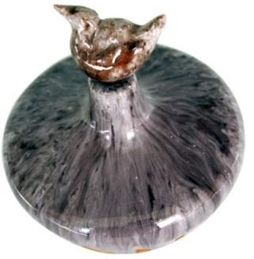

**Image 1:** Alkaline- Boron Glaze, 2008

(must be 11-point size, no spacing)

**CONCLUSION AND DISCUSSION**

It is recommended to begin the conclusion section on a new page.

When writing the conclusion, it is important to avoid using quotations. Instead, it is recommended to discuss the findings of the study and provide any relevant suggestions or guidance.

**BIBLIOGRAPHY**

The bibliography should start on a separate page. The bibliography should be created according to the rules of **“Apa 6”.**

* In-text reference should be in the form of surname, publication year, page number (Öztürk, 2016:35). The source person can be given in the text as surname and the date of the interview (Kaya, 2023).

In the bibliography, information as to the source person and interview, can be given in the form of name-surname, profession, age, place of residence.

* Quotations longer than 4 lines are given as long quotations in the text. They should be written 1 cm inside, 11-point size and italic.

*As a result of the information obtained, it has become important to determine the arrival time of the Young Master in the village in order to determine the start date of the local pottery. For this reason, a field study was conducted in Borcka between 22-23 September 2018 and 19-21 October 2018, with the thought that the clarification of the Young Master's situation would shed light on the pottery history of Şavşat-Küplüce Village. In the study, researches on both traditional Borcka pottery and the Young Master were conducted (Öztürk,2019:280).*

**ONLINE RESOURCES**

<https://www.ardahan.edu.tr/tum-haber-duyuru.aspx?type=0>